
PROJECT TITLE | TECH WORKFORCE SALARY &  FINANCIAL ANALYTICS DASHBOARD
PROJECT CATEGORY | HR Analytics  Salary Analytics  Financial Analytics  Workforce Analytics
INSTITUTE NAME | Infinity Code Nexus
TRAINER / GUIDE | Anand Kumar Anamaina
CREATED BY | D.Usha Arvishi
TOOLS USED | Power BI Desktop Power Query, DAX & Power BI Service
SUBMISSION DATE | [09/06/2026]
Prepared as part of the Power BI Masterclass Program to demonstrate skills in Data Analysis, Data Modeling, DAX Development, Dashboard Design, UI/UX, Storytelling, and Business Intelligence Reporting.

PROJECT OVERVIEW
================================================================
PROJECT OBJECTIVE
Develop a comprehensive Power BI dashboard to analyze employee compensation, career growth, expenses, savings, skills, and workforce satisfaction within the technology industry.

Participants are expected to:
✔ Analyze salary structures
✔ Evaluate career growth
✔ Understand employee expenses
✔ Analyze savings patterns
✔ Assess job satisfaction
✔ Generate business insights
PROJECT GOAL
Transform workforce and financial data into actionable insights that help organizations understand employee compensation, retention, financial well-being, and workforce trends.

BUSINESS PROBLEM
Technology organizations need to understand how salaries, skills, experience, education, expenses, and job satisfaction influence employee performance and retention.
The objective is to identify:
- Which technology fields offer higher compensation?
- How experience impacts salary?
- Do certifications increase income?
- How much do employees save annually?
- What factors influence job satisfaction?
- Which employees are most likely to seek new opportunities?
BUSINESS QUESTIONS
Participants must answer:
- What is the average salary?
- Which technology field pays most?
- Which job roles earn the highest salaries?
- How does experience affect salary?
- Do certifications increase pay?
- Which expenses consume the highest income?
- Which employee groups have higher job satisfaction?

DATASET INFORMATION
================================================================
DATASET NAME : Tech Salary Dataset

DATASET DETAILS : Approximate Records 10,000+

Columns : 50

Power-query Trasformations
===============================================================

DATA CLEANING ACTIVITIES
✔ Removed Duplicate Records
✔ Handled Missing Values
✔ Corrected Data
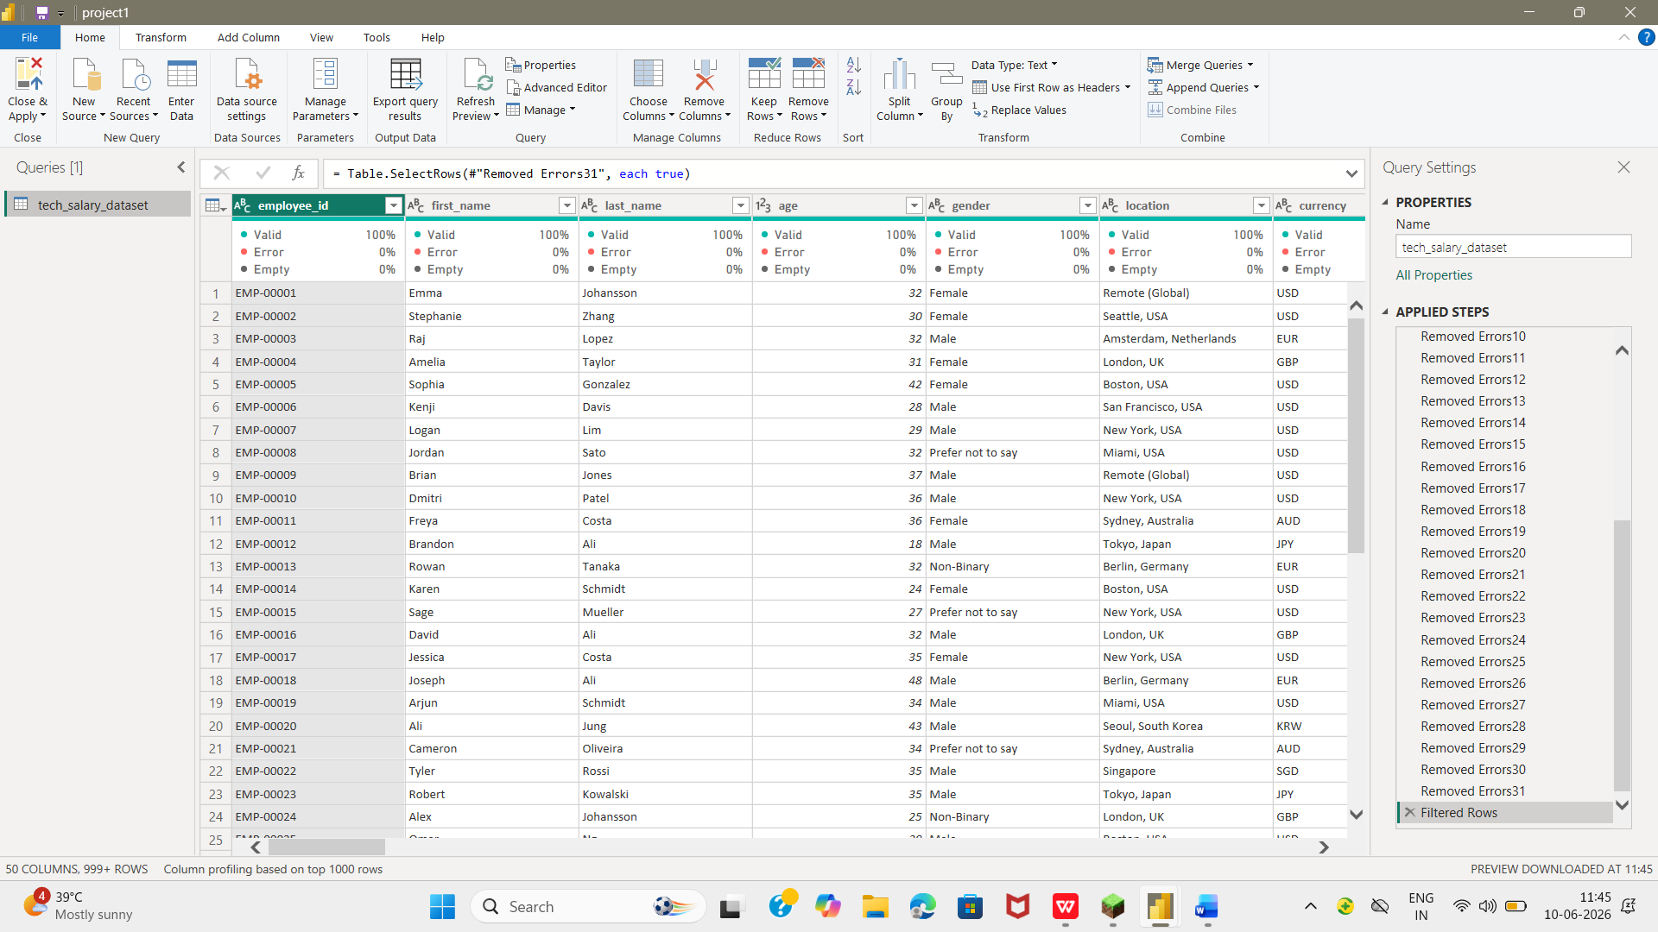

DATA PREPARATION ACTIVITIES
✔ Renamed Columns
✔ Removed Unnecessary Columns

Data Model
Single table data model used for analysis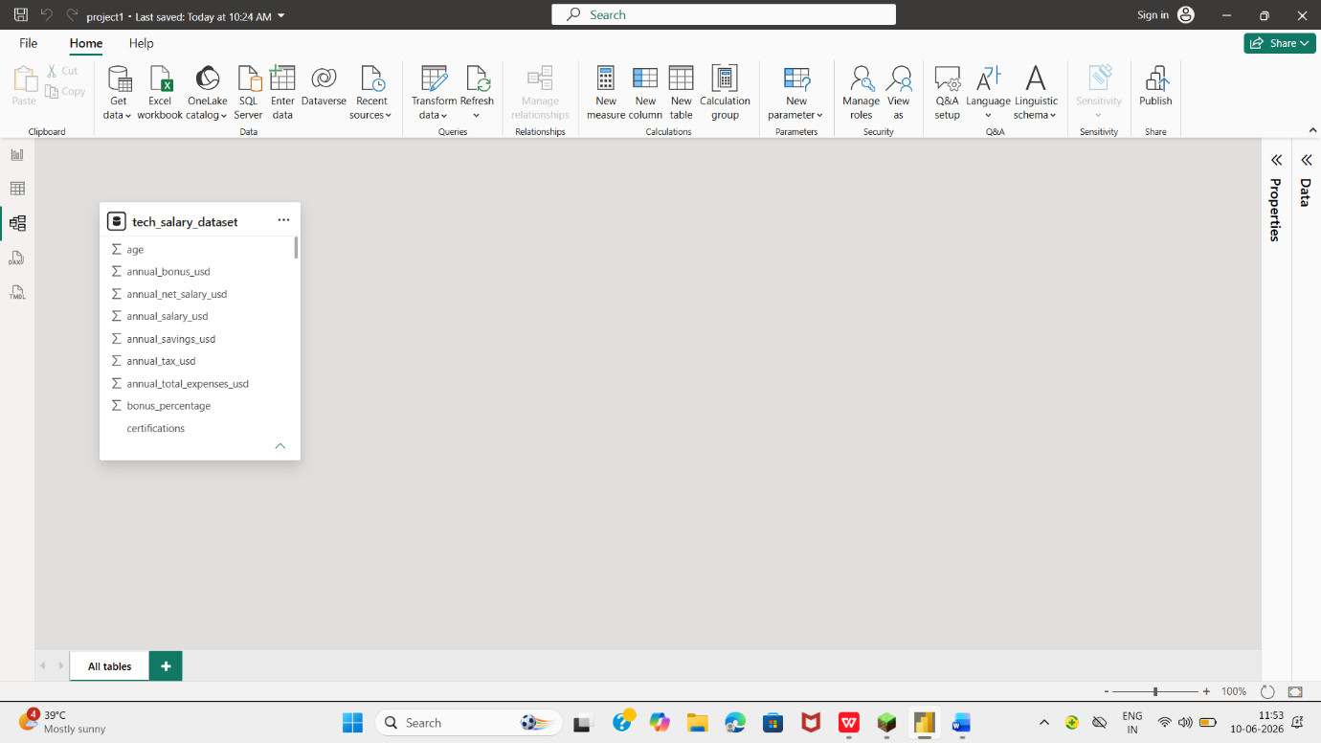

EXPECTED OUTCOME ================================================================
Participants should demonstrate:
✔ Data Understanding
✔ Data Analysis
✔ KPI Development
✔ Dashboard Design
✔ Storytelling
✔ Business Recommendations

DAX MEASURES USED

TOTAL EMPLOYEES:

Total Employees = COUNT(tech_salary_dataset[employee_ID])
PURPOSE: Calculates total employees

AVERAGE SALARY:
AVG SALARY = AVERAGE(tech_salary_dataset[annual_net_salary_usd])
PURPOSE: Calculates average salary
MAXIMUM SALARY:
MAX SALARY = MAX(tech_salary_dataset[annual_salary_usd])
PURPOSE: Calculates maximum salary
FEMALE COUNT:
FEMALE = CALCULATE(COUNTROWS(tech_salary_dataset), tech_salary_dataset[gender] = "Female")
PURPOSE: Calculates female employee count
MINIMUM SALARY :
MIN SALARY = MIN(tech_salary_dataset[annual_salary_usd])
PURPOSE: Calculates minimum salary
TOTAL SALARY:
TOTAL SALARY = SUM(tech_salary_dataset[annual_salary_usd])
PURPOSE: Calculates total salary
VISUALIZATIONS USED
==================================================
KPI CARDS:
Display’s data
SCREENSHOT:
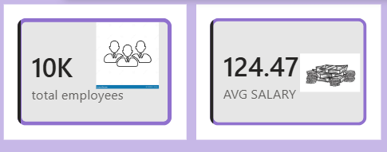
BAR CHART:
Compares average salary and average bonus
SCREENSHOT:
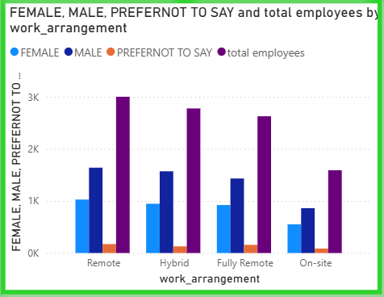
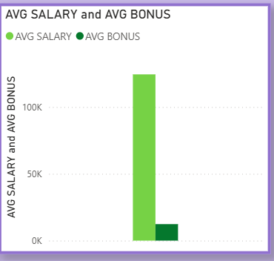
LINE CHART:
Show total salary by skills
SCREENSHOT:
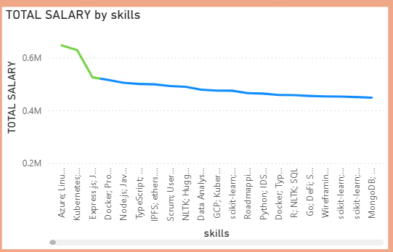

PIE / DONUT CHART:
Show contribution by category and segment.
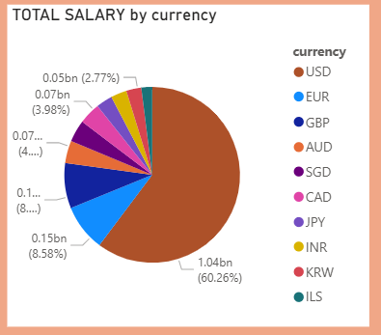
SCREENSHOT:
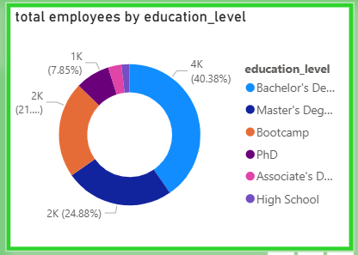
MAP VISUAL:
Analyze employee location
SCREENSHOT:
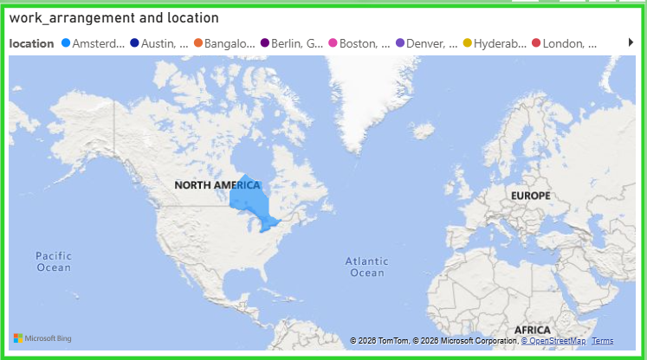

DASHBOARD REQUIREMENTS
================================================================
Participants must create a minimum of 6 Dashboard Pages covering all major workforce, salary, and financial analytics areas.

1.EXECUTIVE OVERVIEW
================================================================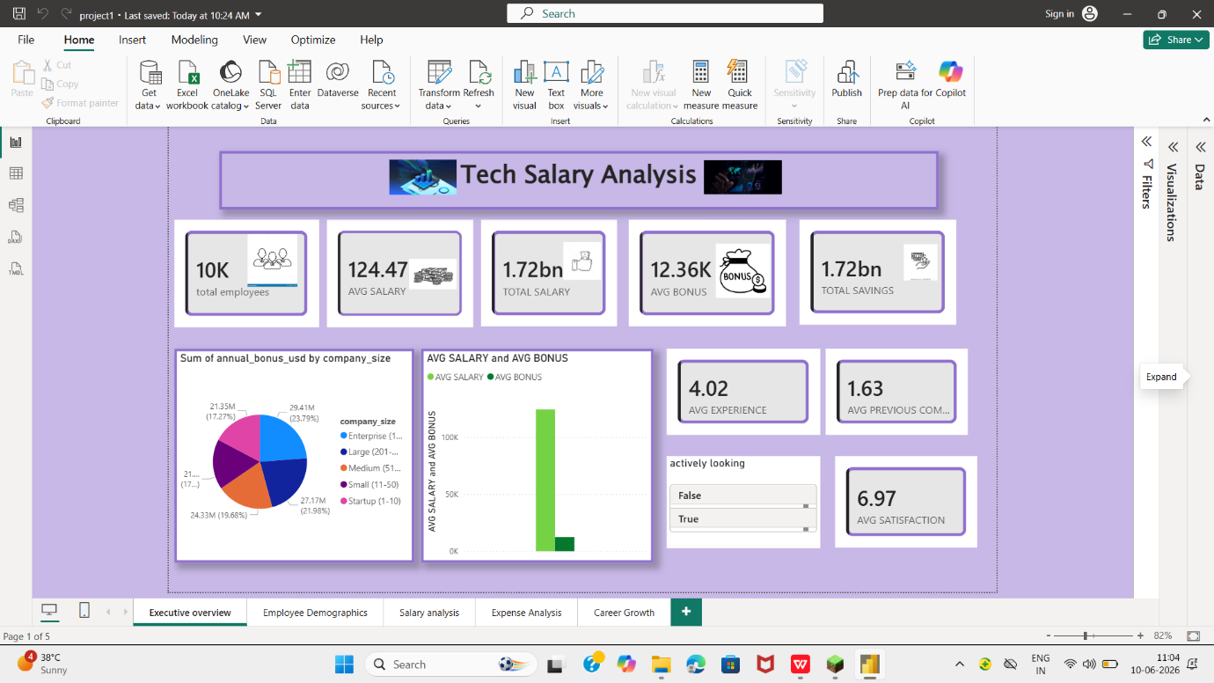Purpose: Provide a high-level summary of workforce compensation, savings, expenses, and employee satisfaction.
✔ Total Employees
✔ Average Annual Salary
✔ Average Annual Savings
✔ Average Bonus %
2.SALARY ANALYTICS
================================================================
Purpose: Analyze compensation patterns across roles, skills, and technology domains.
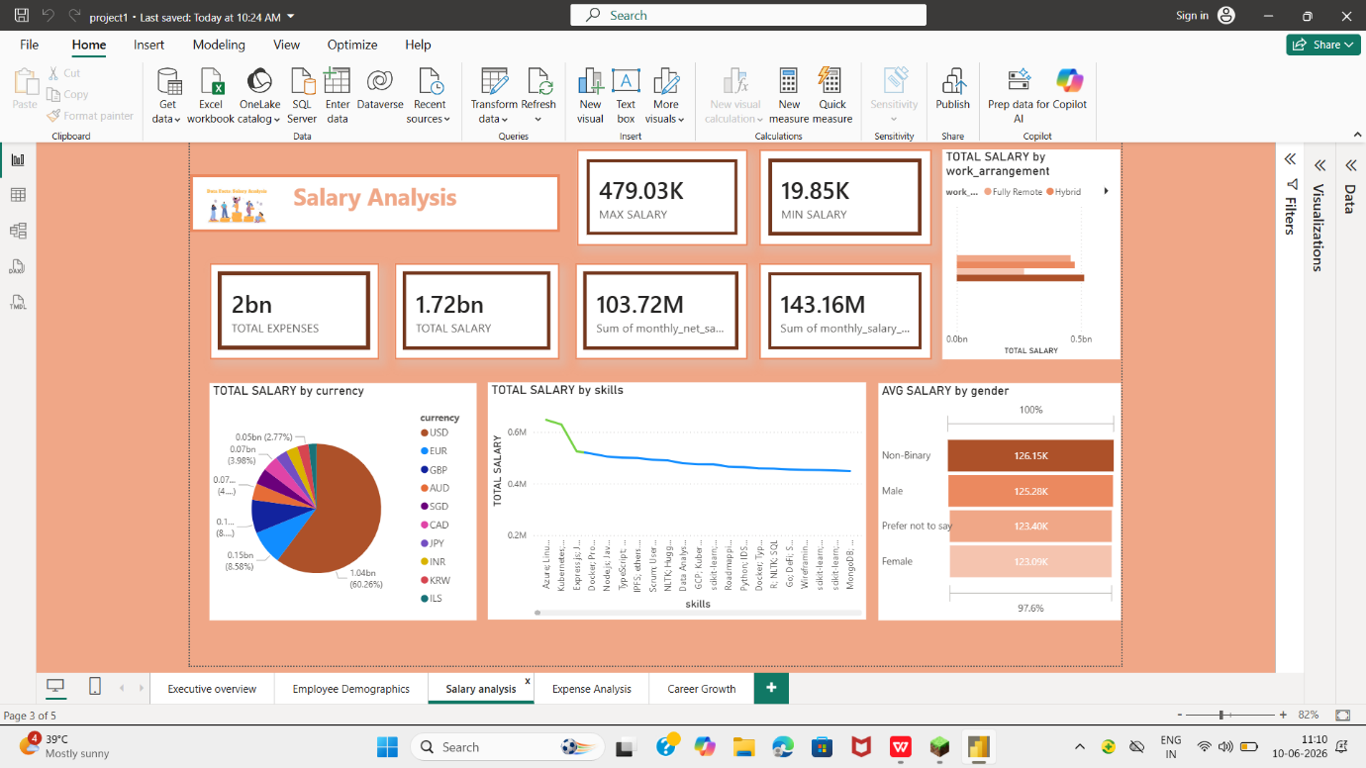
✔Salary by skills
✔Salary by currency
✔ Avg Salary by gender
✔Salary by Education Level
3.CAREER GROWTH ANALYTICS
Purpose: Explains career growth and promotion of employees
✔Experience vs Salary
✔Promotion Analysis
✔Previous Companies Analysis
✔Education Impact on Salary
✔Career Progression Insights

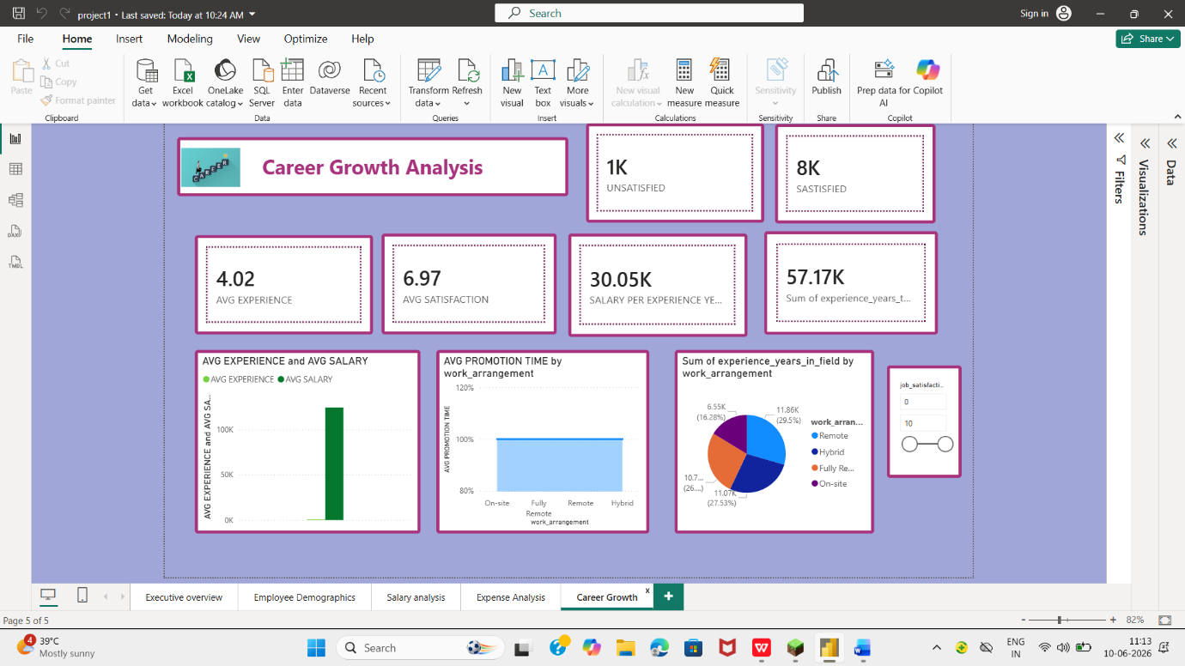

4.EXPENSES & SAVINGS ANALYTICS
================================================================
Purpose: Analyze employee financial health and spending patterns.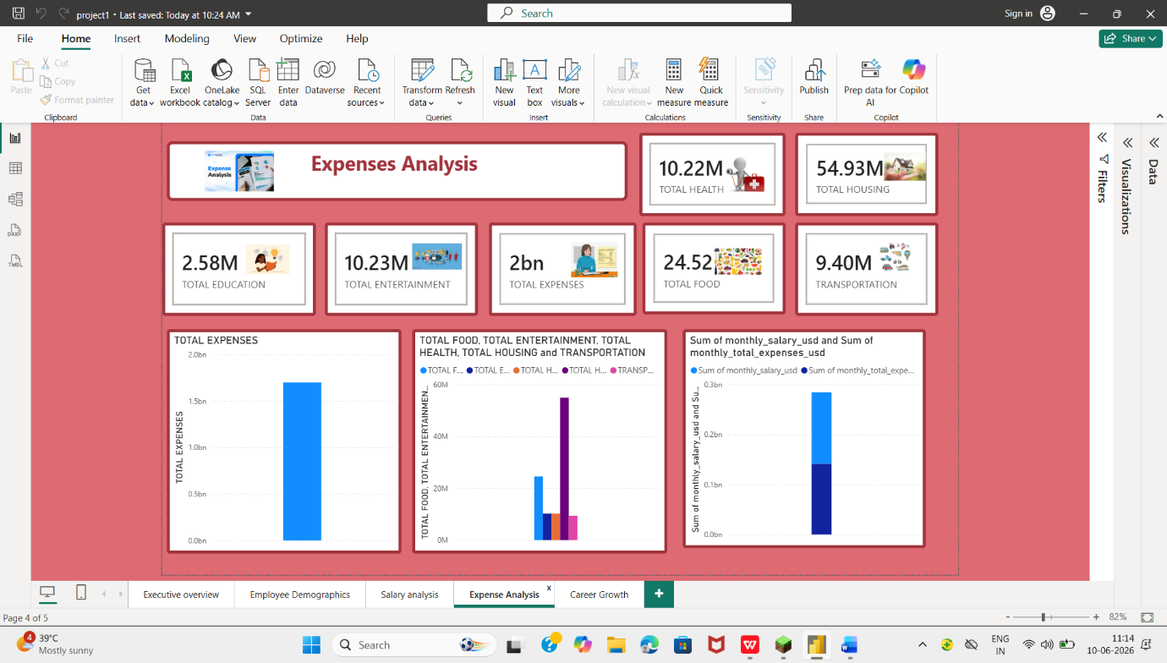
✔Expense Breakdown
✔Housing Expenses
✔Transportation Expenses
✔Annual Savings Analysis
✔Food expenses

5.Employee Demographics
================================================================
Purpose: To Analyse Gender, Education level
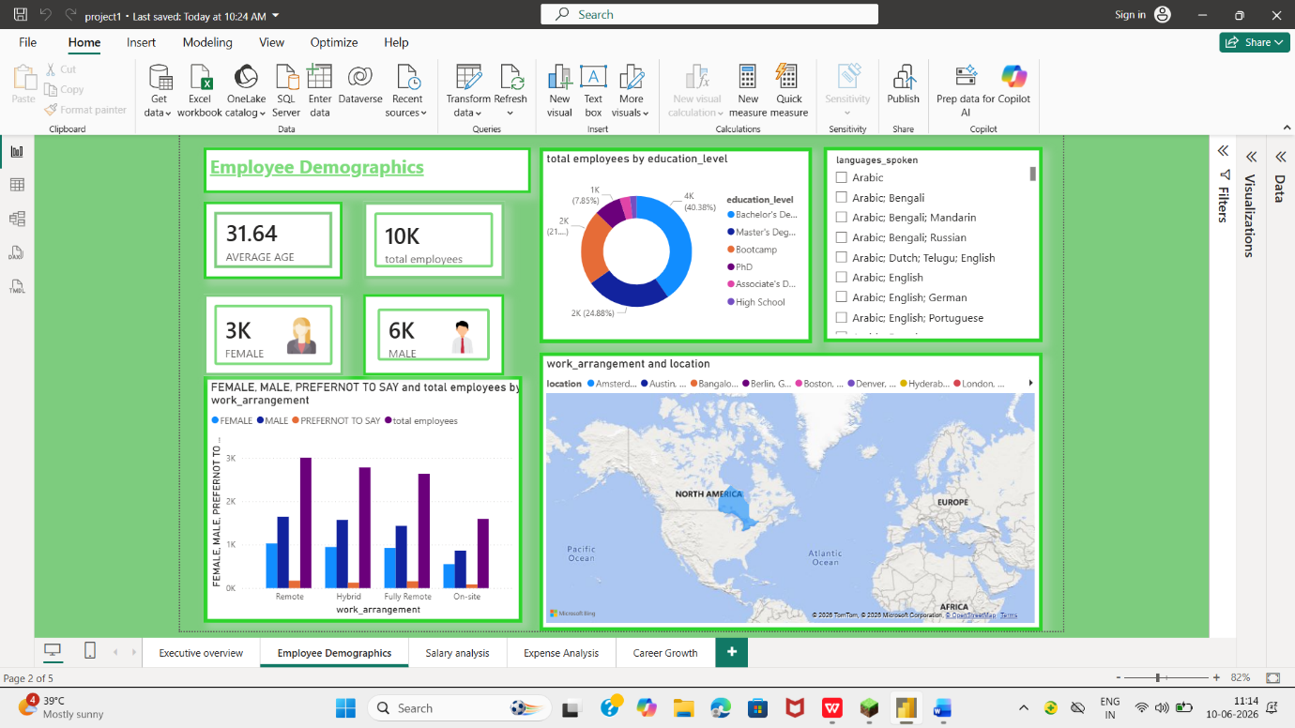Required Analysis
✔Gender distribution
✔Education level
✔Average age
✔Work Arrangement Analysis
✔Location

FEATURES IMPLEMENTED
================================================================
✔ Dynamic Titles
✔ Slicers
✔ Conditional Formatting
✔ Navigation Buttons
✔ Bookmarks
✔ Custom Theme

CHALLENGES FACED
================================================================
Data Cleaning Challenges
Relationship Management
DAX Optimization
Dashboard Layout Design
Performance Tuning

LEARNINGS
================================================================
Power Query
Data Modeling
DAX Development
Dashboard Design
Storytelling
Business Analysis

BUSINESS IMPACT
This project creates a strong impact by turning raw salary data into meaningful insights. It helps organizations design fair and competitive pay structures, which improves employee satisfaction and reduces turnover. By identifying salary trends across roles, skills, and regions, companies can plan budgets more effectively and make smarter hiring decisions. The project also supports diversity and inclusion by highlighting pay gaps, ensuring transparency in compensation. Overall, this analysis strengthens workforce strategy, improves decision-making, and enhances the organization’s ability to stay competitive in the tech industry.

BUSINESS RECOMMENDATIONS
• Review compensation policies regularly to stay aligned with industry standards.

• Use salary insights for workforce planning and budgeting to avoid overspending.

• Address pay gaps to promote fairness, transparency, and employee trust.

• Integrate dashboards into HR systems for continuous monitoring of salary trends.

• Leverage insights for talent retention by offering competitive and equitable pay.

PROJECT DEPLOYMENT
======================================================================
DEPLOYMENT PLATFORM
Power BI Service
DEPLOYMENT PROCESS
STEP-1
Validate Data Model and DAX Measures in Power BI Desktop.
STEP-2
Optimize Dashboard Layout, Performance, and User Experience.
STEP-3
Publish PBIX File to Power BI Service.
STEP-4
Configure Dataset Refresh Settings.
STEP-5
Create Dashboard from Published Reports.
STEP-6
Apply Security and Access Permissions.
STEP-7
Share Dashboard with Business Stakeholders.

BUSINESS BENEFITS
This project provides clear business benefits. It helps companies understand salary trends across different roles, skills, and locations, which supports better workforce planning and budgeting. By comparing pay levels, organizations can ensure competitive compensation to attract and retain talent. The analysis also highlights pay gaps, promoting fairness and transparency in salary structures. Overall, it enables HR and management teams to make data-driven decisions, reduce employee turnover, and stay aligned with industry standards.

CONCLUSION
This project provides valuable insights into salary patterns across different roles, skills, and regions in the technology sector. By using interactive dashboards and visualizations, the project makes complex data easy to understand and supports better decision-making for HR, finance, and management teams. It helps organizations plan budgets, ensure fair pay, and stay competitive in attracting and retaining talent. Overall, this project demonstrates how data-driven analysis can improve workforce strategies and create long-term business value.

